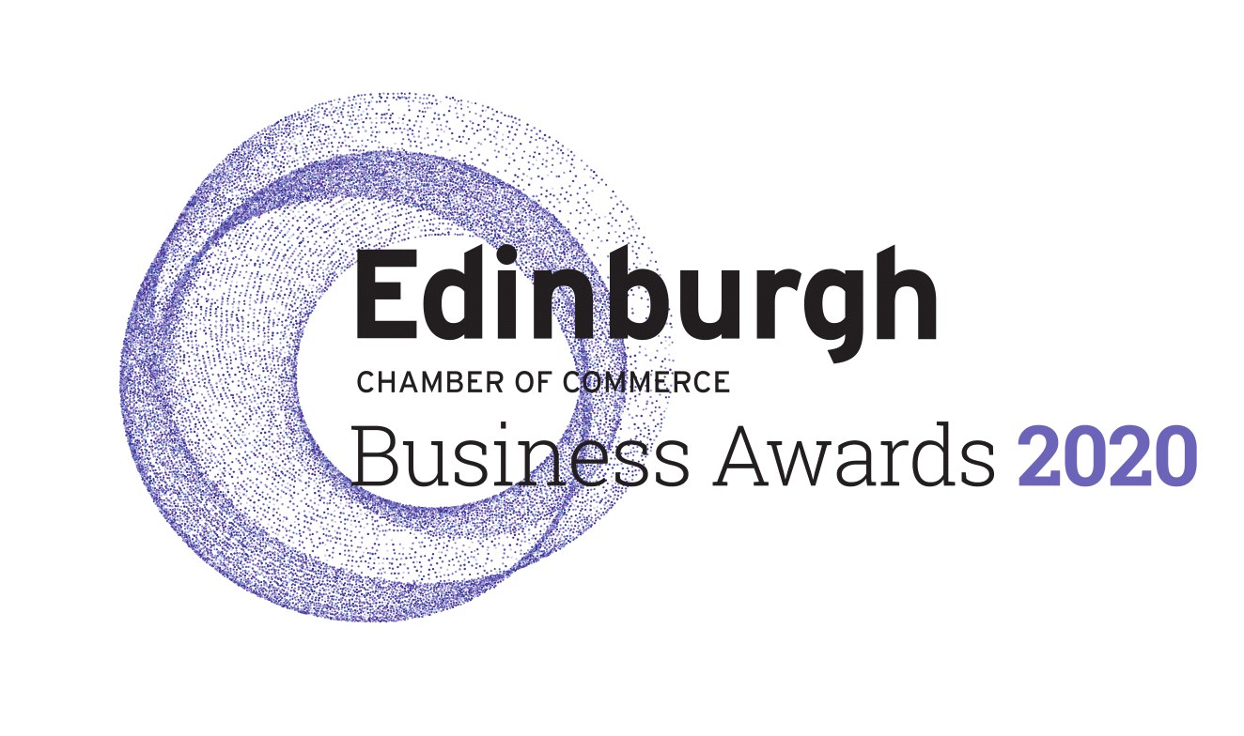
This document provides guidance on the categories for the Edinburgh Chamber of Commerce Business Awards 2020, detailing the criteria that the judges will be considering when shortlisting finalists and selecting category winners. Any queries on these should be directed here.
Microbusiness of the Year – sponsored by Business Gateway
- Open to businesses with less than 10 staff
- Must demonstrate strong managerial and financial performance
- Commitment to growing and developing a dynamic workforce
- Evidence of innovation to differentiate product and services
Mid-Sized Business of the Year – Wright, Johnston & Mackenzie LLP
- Open to businesses with between 10-100 Staff
- Must demonstrate strong managerial and financial performance
- Commitment to growing and developing a dynamic workforce
- Evidence of innovation to differentiate product and services
Large Business of the Year
- Open to businesses with more than 100 Staff
- Must demonstrate strong managerial and financial performance
- Commitment to growing and developing a dynamic workforce
- Evidence of innovation to differentiate product and services
Responsible Business – sponsored by City of Edinburgh Council
- Commitment to conducting business in a socially conscious manner
- Dedication to the wellbeing of the local community
- Evidence of sustainable practice implemented through the business strategy
Innovation in Business – sponsored by Forth Ports
- A high degree of creativity and dynamism in developing your business
- Demonstrable innovative methods or approach to differentiate from competitors
- Evidence of improved commercial performance, customer satisfaction or operational efficiency
Marketing Campaign of the Year
- A campaign with clearly defined target market and objectives
- Successful execution of an innovative marketing campaign
- Evidence of campaign effectiveness in reaching desired objectives and return on investment
Director of the Year – sponsored by Royal Bank of Scotland
- Exceptional leadership skills
- Evidence of the individuals impact on the business strategy, direction and performance
- Clearly defined vision for continual performance
High Growth Business of the Year – sponsored by Edinburgh Airport
- Evidence of substantial growth
- Implementation of a strong development plan
- Clear strategies to continue high growth in to the future
Export Business of the Year
- Clearly defined strategy for international growth
- Evidence of expansion in to new international markets
- Demonstrable commercial impact of internationalisation on their business
Developing the Young Workforce – sponsored by Developing the Young Workforce
- Evidence of shaping and inspiring young people whilst in education
- Commitment to recruitment and development of young people
- Wider engagement with education providers to support Scotland’s youth employment strategy
Employer of the Year – sponsored by Edinburgh Trams
- Clearly defined company values and examples of how employees are aligned with them
- Implementation of initiatives to benefit employees including health and wellbeing schemes and the benefit of these on employees
- Demonstrable commitment to employee development and that creates a stimulating and supportive workplace
Lifetime Achievement
n/a
Young Leader of the Year – sponsored by Turcan Connell
- Open to individuals aged 35 or under
- Evidence of exceptional leadership skills
- Significant contribution to their organisation
- Acts as a role model to others

Inspiring Partnership
- A clearly defined partnership with a third sector organisation
- Evidence of a beneficial relationship to both the organisations and community beyond solely financial performance, with a clear plan to maintain a sustainable and mutually beneficial impact for both parties in the future.
- Evidence that the partnership has resulted in organisational change for both partners, embedding the partnership values into the company’s culture and operations.
Circular Economy Innovation Award – sponsored by Circular Edinburgh
- A project or organisation that demonstrates innovation around implementing and demonstrating creative solutions around waste reduction or elimination
- Embedding Circular economy thinking to core business practices, sustainability and corporate responsibility with support by senior management
- Evidence of the organisation consistently working towards a ‘zero waste’ policy across projects that encourage collaborations with partners, employees and the supply chain

Service Excellence Award – sponsored by Stagecoach
- Evidence of a commitment to delivering the best experience and service for customers
- A clearly defined process in place to ensure service is delivered
- Evidence of customer satisfaction surveys and/or customer endorsements

